EXPERIMENT 1

**CODE**

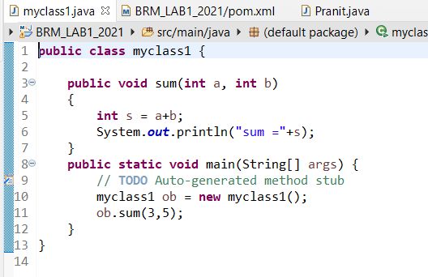

**POM.XML**

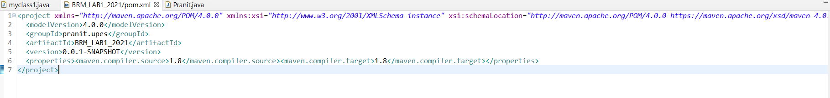

**PACKAGE INFO**

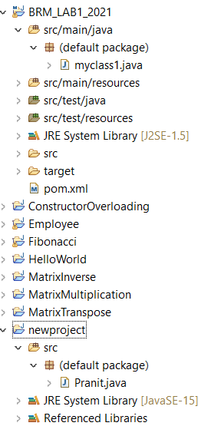

**CLEAN COMMAND AS MAVEN BUILD…**

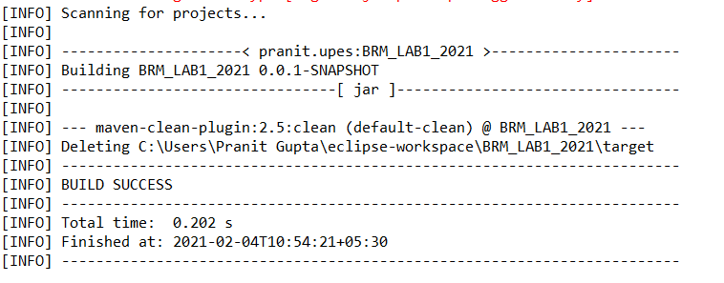

**COMPILE COMMAND AS MAVEN BUILD…**

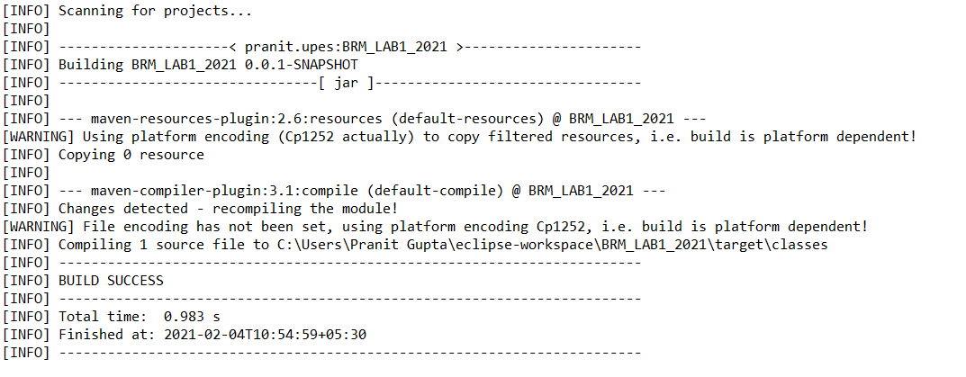

**INSTALL COMMAND AS MAVEN BUILD…**

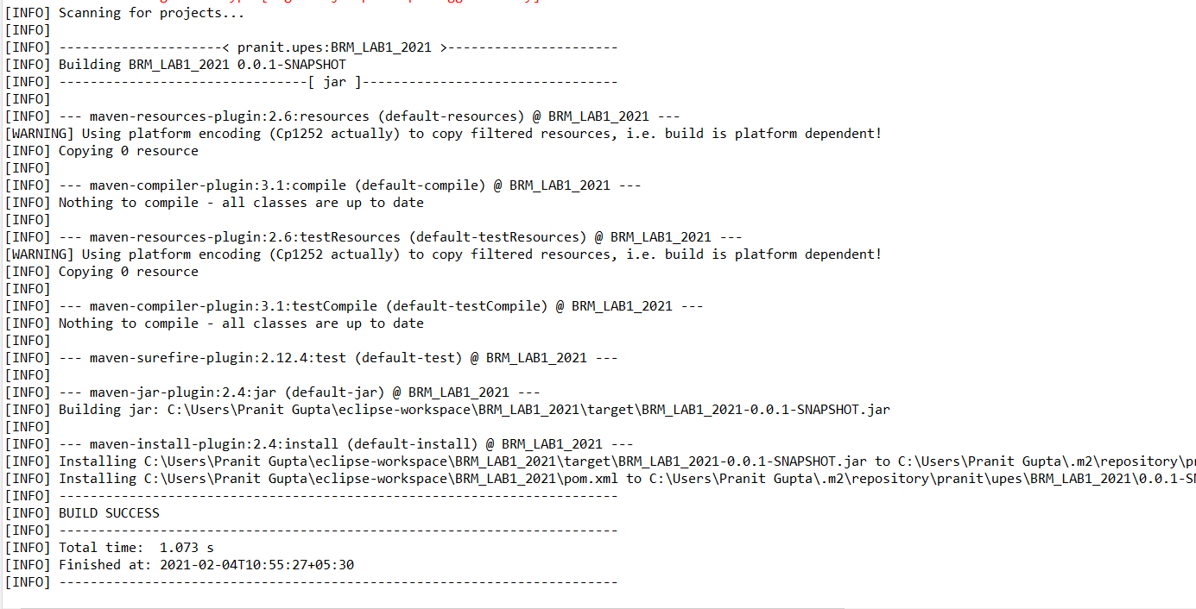

**JAVA PROJECT FILE FOR RUNNING MAVEN PROJECT**

